The annual Lakeside Artists Studio Tour (LAST) is a popular cultural event in the Lake Norman region. Since 2009, a group of volunteer artists located on the Brawley peninsula has organized an annual art sale offering tours of our open studios and additional sites where multiple artists may offer their work. Media have included wood, ceramics, paintings, sculpture, fiber, furniture, jewelry, glass, photography, metalwork and more. Patrons look forward to this event, and we have enjoyed excellent attendance attracted by publicity, word of mouth and the high quality of work offered by participating artists. The tour extends Friday through Sunday and typically includes 6 locations. Our tag line, “one-of-a-kind art, directly from the artists,” promises that patrons will find unique works of art they won’t find everywhere else.

THE TOUR locations each display several artists for the convenience of our visitors. Artists may be guests at a participating studio or host their own studio location on the Brawley peninsula. While we focus on being a studio tour, we typically provide the opportunity for some visiting artists to occupy other appropriate community sites. No single location will have more than one artist offering work in a particular medium/style. A typical tour site might, for instance, include a painter, a wood artist, and a jewelry artist. To ensure variety at each location, it may be necessary to limit the number of artists accepted in a particular medium, irrespective of the quality of the submission.

THE MARKETING includes publicity in a variety of local publications and media outlets. Large banners are posted in prominent locations in the weeks preceding the show. Signs direct visitors to each studio location on the dates of the show. High quality 11” x 6” glossy postcards are mailed to residences on the Brawley peninsula and nearby key neighborhoods, and similar save-the-date standard postcards are available for early promotion. Both are available to participating artists for distribution. We maintain a professional website that artists may reference in email communications, social media, and on other websites. The LAST website features a page for each studio tour location and features each participating artist to showcase their work and link to their individual websites. The website currently features art from previous tours, but you may visit http://www.LKNstudiotour.com to see the layout. We also actively promote the event and individual artists on our Lakeside Artists Studio Tour Facebook page.

THE APPLICATION process requires submitting photos of your current work to be juried, regardless of previous participation in LAST tours. Before applying please read the full prospectus, complete and sign the application agreeing to the artist rules, and send separate checks as described below for the application fee and tour participation. Send new images of your work suitable to be published on the post card, website, etc. No previously used images will be accepted.

FEES are set based on the promotion costs (primarily printing the show postcards and direct mail postage to homes located in the area) as well as site rental costs if necessary. LAST is a not-for-profit, all-volunteer group whose budget includes only expenses related to the tour. A non-refundable application fee of $25.00 is due with the application for the jury process. Please submit a separate registration check for $200 to contribute to tour expenses. If entering in more than one category (such as painting and sculpture, or ceramics and jewelry), an additional $25 tour fee will apply. If your work is not accepted for this show, your tour participation check will be returned uncashed. Late registrations are subject to a $25 late fee. Please make checks payable to Lakeside Artists Studio Tour and mail to Lakeside Artists, 116 Scottsdale Lane, Mooresville, NC 28117.

.2023 Show Schedule:
April Artist outreach begins
May Save the date postcards available
June - Oct Solicitation of sponsors
July 1 Deadline to receive artist applications
July 15 Jury decisions and notification of selected participants
August 1 Artist assignments to locations
August Organization meeting for all artists
October 1 Distribution/mailing of marketing postcards
October 26 Set up during the day followed by preview at 5:00 pm
October 27 Opening Day 10 am – 5 pm
October 28 Second Day 10 am – 5 pm
October 29 Closing Day 12 noon – 4pm
IMAGES: The jury process requires that you submit high quality images of 3 individual pieces of your work to be evaluated. Please set your camera (or phone) to save images at its highest possible density (most pixels per inch) to insure good replication in our printed and web-based marketing. Save the images with file names structured to contain: Last name, First initial, art piece number 1-3, and the year. e.g., SmithJ12023.jpg, SmithJ22023.jpg, SmithJ32023.jpg.
Email your images to Info@LKNstudiotour.com or cnluttrell@gmail.com by the July 1 deadline.
FEES: Mail $25.00 jury fee + $200 regular application fee checks to arrive prior to the July 1 deadline for applications. Late registrations are subject to a $25 late fee. Mail to:
Lakeside Artists
116 Scottsdale Lane
Mooresville, NC 28117.
Although every effort will be made to include an image from every artist, based on design layout and number of participants, we cannot guarantee that your image will appear on the postcard. However, every artist will be featured on the LAST website displaying their qualifying images, information, and website link. The following are the fronts of the 11” x 6” postcards from previous tours.
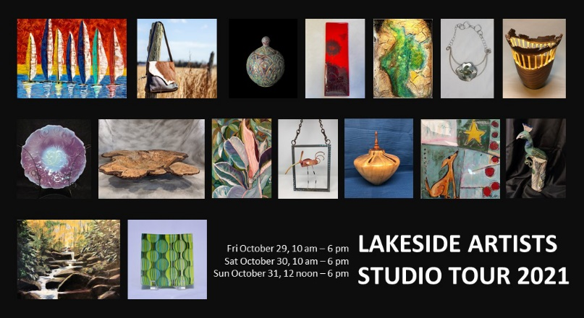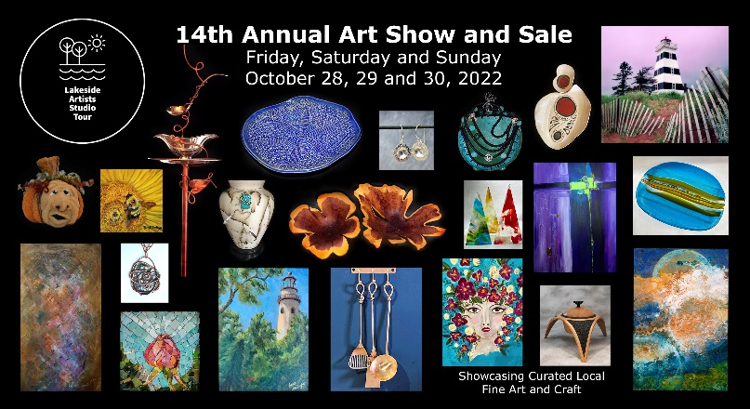

GUIDELINES:

All tour sites will be located along the Brawley School Road corridor, south of Williamson Road. Guest artists will be accommodated in open home studios or other appropriate community spaces.

All artwork must be original, unique fine art - no class or workshop work. At least 75% of all artwork displayed must be original media – less than 25% of your art can be prints, giclées (on canvas or paper), or any type of printed reproduction (including those which have medium added to them), with the exclusion of note cards, prints in the artistic medium of printmaking and photographs of subject matter that is not your original art.

Our goal is to promote a quality fine art event; therefore, your work should be displayed as professionally as possible. Your contact information, phone and email address will be shared with other artists displaying at the same location so you can coordinate logistics, etc.

ARTIST RESPONSIBILITIES: You will be asked to help publicize the tour to your customer/patron list. You will be provided professional looking content for the event to email twice - a “Save the Date” and another show announcement closer to the event which will serve as a reminder notice. Event postcards will be available for you to distribute in the community, at events, and by mail.

Coordination of refreshments and snacks will be done by the artists at each location with leadership from the host/owner. If you are in a community space, the artists assigned to the site will coordinate their set up, refreshments (if permitted), etc. Hosts may need assistance with preparation of their home, moving furniture and clearing the way for artwork to be displayed. You will also be expected to assist in restoring the venue (home or community space) back to its original condition.

You must be present to set up by Thursday evening. A preview for the participating artists will follow set up, and all of your items should be in place and priced for the 5 p.m. artists’ preview tour. You must also be present 15 minutes prior to opening on Friday, Saturday and Sunday and stay the entire time. Closing before the published daily tour end times is not permitted. Clean up will follow closing on Sunday evening unless you have made other arrangements with the host.

You may be required to assist in placing the signage for the site where you are located.

Failure to abide by any of the above rules will disqualify you from future Lakeside Artist Studio Tours.

Please send any questions by email to info@LKNstudiotour.com

PLEASE PRINT AND COMPLETE THE APPLICATION, SIGN THE LIABILITY WAIVER, AND RETURN BOTH WITH CHECKS BY THE REGISTRATION DEADLINE OF JULY 1, 2023

Only one artist and one art form per application.

Artist Name: ______________________________ Business Name: ______________________
(As you would like printed in materials)

Mailing Address: ______________________________________________________________

City: ________________________ State: ____ Zip: __________

Phone: Home: ________________ Business: ________________ Cell: ___________________

Email: ______________________________ Website: ____________________________

Host Studio or Guest Artist? __________________
Host Studios must be located on the Brawley School Road Peninsula
If Host - how many artists of different media can you accommodate? ____________

Your Medium: ____________________________Usual price Range $_________to $_________

Images Submitted

example: SmithJ01LAST2023.jpg Price of this item

1____________________________ $___________

2____________________________ $___________

3____________________________ $___________

Signature: ___________________________________________________________
You signature indicates you have read the full prospectus and agree to the terms.

A non-refundable jury fee of $25.00 for each art form as well as an additional $200 participation fee is due with your application. The $200 will be returned if your work is not accepted. Please make checks payable to Lakeside Artists Studio Tour, delivered no later than July 1, 2023.

Mail to: Lakeside Artists, 116 Scottsdale Lane, Mooresville NC 28117

WAIVER AND RELEASE OF LIABILITY
page 1 of 2

In consideration of the risk of injury while participating in Lakeside Artists Studio Tour 2023 (the "Activity"), and as consideration for the right to participate in the Activity, I hereby, for myself, my heirs, executors, administrators, assigns, or personal representatives, knowingly and voluntarily enter into this waiver and release of liability and hereby waive any and all rights, claims or causes of action of any kind whatsoever arising out of my participation in the Activity, and do hereby release and forever discharge Lakeside Artists, located at Mooresville, North Carolina, their affiliates, managers, members, agents, attorneys, staff, volunteers, heirs, representatives, predecessors, successors and assigns, for any physical or psychological injury, including but not limited to illness, paralysis, death, damages, economical or emotional loss, that I may suffer as a direct result of my participation in the aforementioned Activity, including traveling to and from an event related to this Activity.

I AM VOLUNTARILY PARTICIPATING IN THE AFOREMENTIONED ACTIVITY AND I AM PARTICIPATING IN THE ACTIVITY ENTIRELY AT MY OWN RISK. I AM AWARE OF THE RISKS ASSOCIATED WITH TRAVELING TO AND FROM AS WELL AS PARTICIPATING IN THIS ACTIVITY, WHICH MAY INCLUDE, BUT ARE NOT LIMITED TO, PHYSICAL OR PSYCHOLOGICAL INJURY, PAIN, SUFFERING, ILLNESS, DISFIGUREMENT, TEMPORARY OR PERMANENT DISABILITY (INCLUDING PARALYSIS), ECONOMIC OR EMOTIONAL LOSS, AND DEATH. I UNDERSTAND THAT THESE INJURIES OR OUTCOMES MAY ARISE FROM MY OWN OR OTHERS' NEGLIGENCE, CONDITIONS RELATED TO TRAVEL, OR THE CONDITION OF THE ACTIVITY LOCATION(S). NONETHELESS, I ASSUME ALL RELATED RISKS, BOTH KNOWN OR UNKNOWN TO ME, OF MY PARTICIPATION IN THIS ACTIVITY, INCLUDING TRAVEL TO, FROM AND DURING THIS ACTIVITY.

I agree to indemnify and hold harmless Lakeside Artists against any and all claims, suits, or actions of any kind whatsoever for liability, damages, compensation or otherwise brought by me or anyone on my behalf, including attorney's fees and any related costs, if litigation arises pursuant to any claims made by me or by anyone else acting on my behalf. If Lakeside Artists incurs any of these types of expenses, I agree to reimburse Lakeside Artists.

I acknowledge that Lakeside Artists and their directors, officers, volunteers, representatives, and agents are not responsible for errors, omissions, acts or failures to act of any party or entity conducting a specific event or activity on behalf of Lakeside Artists.

I ACKNOWLEDGE THAT I HAVE CAREFULLY READ THIS "WAIVER AND RELEASE" AND FULLY UNDERSTAND THAT IT IS A RELEASE OF LIABILITY. I EXPRESSLY AGREE TO RELEASE AND DISCHARGE Lakeside Artists AND ALL OF ITS AFFILIATES, MANAGERS, MEMBERS, AGENTS, ATTORNEYS, STAFF, VOLUNTEERS, HEIRS, REPRESENTATIVES, PREDECESSORS, SUCCESSORS AND ASSIGNS, FROM ANY AND ALL CLAIMS OR CAUSES OF ACTION AND I AGREE TO VOLUNTARILY GIVE UP OR WAIVE ANY RIGHT THAT I OTHERWISE HAVE TO BRING A LEGAL ACTION AGAINST Lakeside Artists FOR PERSONAL INJURY OR PROPERTY DAMAGE.

To the extent that statute or case law does not prohibit releases for negligence, this release is also for negligence on the part of Lakeside Artists, its agents, and employees.

In the event that I should require medical care or treatment, I agree to be financially responsible for any costs incurred as a result of such treatment. I am aware and understand that I should carry my own health insurance.

WAIVER AND RELEASE OF LIABILITY
page 2 of 2

In the event that any damage to equipment or facilities occurs as a result of my or my agents’ willful actions, neglect, or recklessness, I acknowledge and agree to be held liable for any and all costs associated with any actions of neglect or recklessness.

This Agreement was entered into at arm's-length, without duress or coercion, and is to be interpreted as an agreement between two parties of equal bargaining strength. Both the Participant Artist,
NAME ________________________________, and Lakeside Artists agree that this Agreement is clear and unambiguous as to its terms, and that no other evidence will be used or admitted to alter or explain the terms of this Agreement, but that it will be interpreted based on the language in accordance with the purposes for which it is entered into.

In the event that any provision contained within this Release of Liability shall be deemed to be severable or invalid, or if any term, condition, phrase, or portion of this agreement shall be determined to be unlawful or otherwise unenforceable, the remainder of this agreement shall remain in full force and effect, so long as the clause severed does not affect the intent of the parties. If a court should find that any provision of this agreement to be invalid or unenforceable, but that by limiting said provision it would become valid and enforceable, then said provision shall be deemed to be written, construed, and enforced as so limited.

In the event of an emergency, please contact the following person(s):

Emergency Contact: ____________________________________________________________________

Contact Relationship: __________________________________________________________________

Contact Telephone: ____________________________________________________________________

I, the undersigned participant, affirm that I am of the age of 18 years or older, and that I am freely signing this agreement. I certify that I have read this agreement, that I fully understand its content and that this release cannot be modified orally. I am aware that this is a release of liability and a contract and that I am signing it of my own free will.

Participant's Name: ____________________________________________________________________

Participant's Address: __________________________________________________________________

Signature: ____________________________________________________________________________

Date: ________________________________________________________________________________

